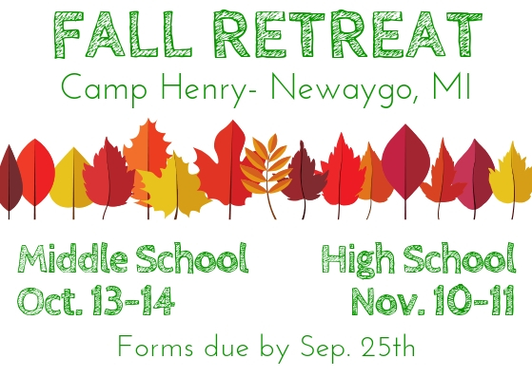
Transportation: Church bus, volunteers’ personal cars if necessary
Lodging: on-site cabins (heated, with bathrooms, bunk beds)
Times: Leave at 7:30am Saturday, return around 4pm Sunday the
Cost: $40 for one youth; $30 per youth for families with multiple youth participating

No youth will be denied participation because of financial need. Scholarships (partial or full) are available through request to Katie Brinklow

About Camp Henry:
Camp Henry’s mission is to provide life-changing experiences for all in a Christian environment. The camps purpose is to be a place that helps individuals to experience a glimpse of the world the way God intended it to be by providing a positive Christian environment where people have life changing experiences and increasing appreciation of the natural world. Camp Henry is a member of the Christian Camp and Conference Association and is accredited by the American Camp Association. Being accredited by the American Camp Association indicates that Camp Henry meets or exceeds industry-accepted and government-recognized standards and best practices for programs, facilities, and staff.

Payment and Forms Due by 4pm September 25th:
- Fall Retreat youth and emergency info form
- Fall Retreat parent and youth liability/code of conduct form
- Camp Henry’s liability form
- $40 or $30 for multiple participants (unless scholarship has been requested)
- (if needed) MPC Youth Ministry 2018-2019 Liability Form

- Youth Participant Information:
Name: ______________________________________________________________
Cell Phone: (______) ______ - __________ Texts? Yes____ No____
___ Middle School (Oct. 13-14)
___ High School (Nov. 10-11)
2018-2019 Liability Form on file? Yes____ No*____ Yes, but need to update* ____
*Please fill out and return with this form

- Parent/Guardian and Emergency Contact Information
Parent/Guardian 1 (this should be the adult that will be the primary contact for the trip)
Name:___________________________________________________
Relationship to Youth: ________________________
Primary Phone: (______) ______ - __________ Texts? Yes____ No____
Parent/Guardian 2 (Secondary or other primary adult)
Name:___________________________________________________
Relationship to Youth: ________________________
Primary Phone: (______) ______ - __________ Texts? Yes____ No____
Parent/Guardian 3 or Emergency Contact (Needs to be a different adult from P/G 1 &2)
Name:___________________________________________________
Relationship to Youth: ________________________
Primary Phone: (______) ______ - __________

- Youth Health and Medical Information
Health concerns or issues (allergies, conditions, injuries etc.):__________________________________
__________________________________________________________________________________________________________________________________________________________________________
Medications taken regularly and/or that may need to be taken (please include drug name, how many/much, when taken and any other “need to know”): ___________________________________________________
__________________________________________________________________________________________

- Payment
___ Check or cash enclosed ($40, or $30 for multiple)
___ Scholarship

- Liability Waiver and Code of Conduct

Parent/Guardian Agreement:
I understand that any activity or travel involves some element of risk, but that the staff and sponsors of Memorial Presbyterian Church (hereafter MPC) will make every effort to avoid such risk to my child. In the event of an emergency, I understand that every effort will be made to contact me. If I cannot be reached, I hereby authorize a representative of MPC of Midland, Michigan, to act on my behalf to seek medically necessary treatment until I can be reached. I absolve MPC and its representatives from liability in acting on my half in this regard, so long as MPC is not grossly negligent. I give MPC permission to use my child’s photo in various media. I give permission for staff and adult volunteers of MPC to provide transportation for this event, and understand that transportation will be provided by church vehicle and/or authorized privately owned vehicle. I understand that all staff and volunteers have been authorized through the Safe Child Policy. I grant permission for my child to participate in this event with MPC. Additionally, I have read and understand the Youth Code of Conduct below, and understand that in the event that my child does not uphold their agreement I may be required to arrange for their immediate transportation home at my expense and forfeit any payments made for their participation in the event.

Parent/Guardian Signature:____________________________________________Date:_____________

Youth Code of Conduct:
I promise to participate and contribute, to the best of my ability, to this event. I will be caring and respectful towards everyone I encounter. I will conduct myself maturely and as a representative of MPC and my family. I will practice responsible, thoughtful and respectful social media use. I will not bring or use any kind of alcohol, tobacco, vaping, drugs, or weapons. During this event I will not have romantic or sexual contact with anyone, including my significant other, other than appropriate hand holding. I will not be in a room alone with someone with the door closed. I will respect and uphold all rules and requests made by MPC staff and adult leaders. I understand that failure to agree to and abide by the above may bar me from participation in activities and, if deemed necessary, require me to return home at my family’s expense.

Youth Signature:_____________________________________________________Date:_____________

